**Applied Industrial Internet of Things**

**1. Room Automation System using Cisco Packet Tracer**

1.The choosen the Mindmap :

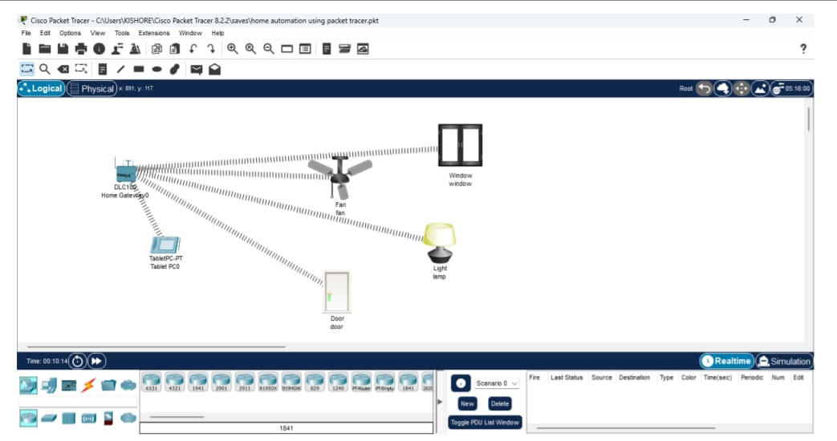

i)conditions according to the work

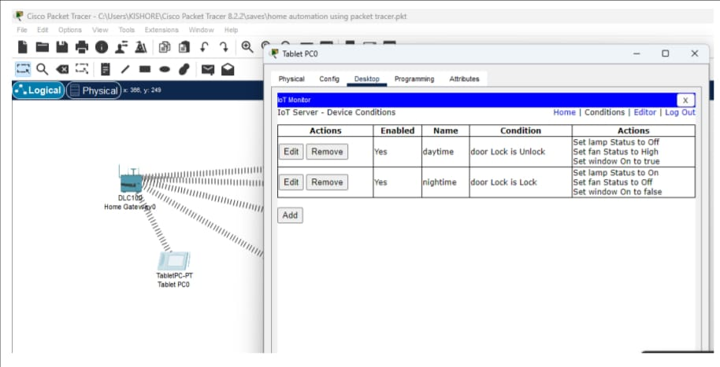

ii) when the door is open

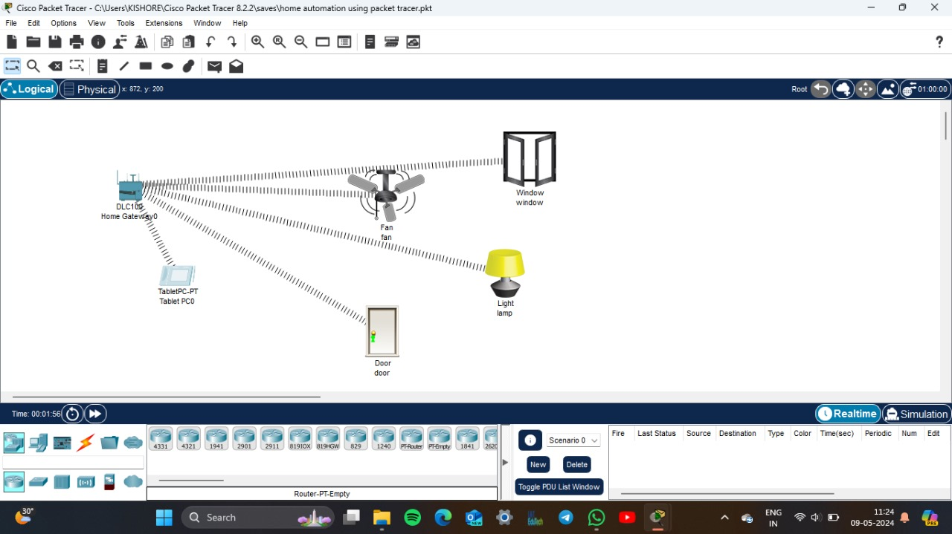

The fan and window will be operated and opened automatically and light will switched off

iii) when Door closed condition 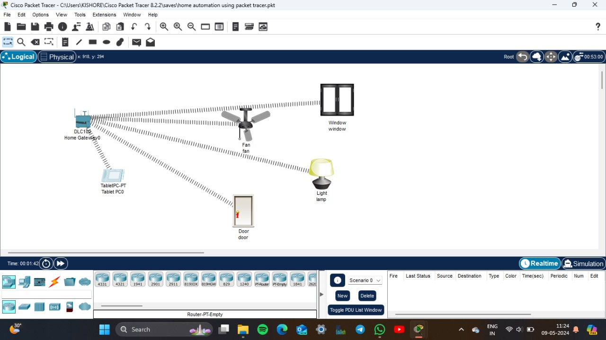

Only the LAMP is switched on and other are at off state

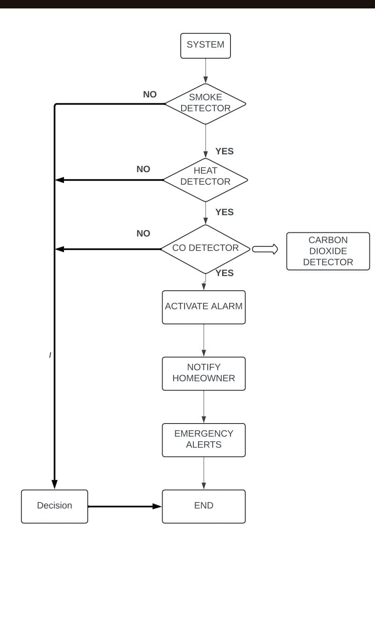 **FIRE DETECTION SYSTEM**

The choosen mind map: